**Math 120  
1.7 Combinations of Functions and Composite Functions**

# Objectives:

1. Find the domain of a function.
2. Combine functions using the algebra of functions, specifying domains.
3. Form composite functions.
4. Determine domains for composite functions (minimally)
5. Write functions as compositions.

# Topic #1: The Domain of a Function

Recall that the domain of a function is the set of all ______________ that prove an output *y*. Some functions do not have domain restrictions, some functions do have domain restrictions.

*A. Domain is _____________________________:*

Consider the function .

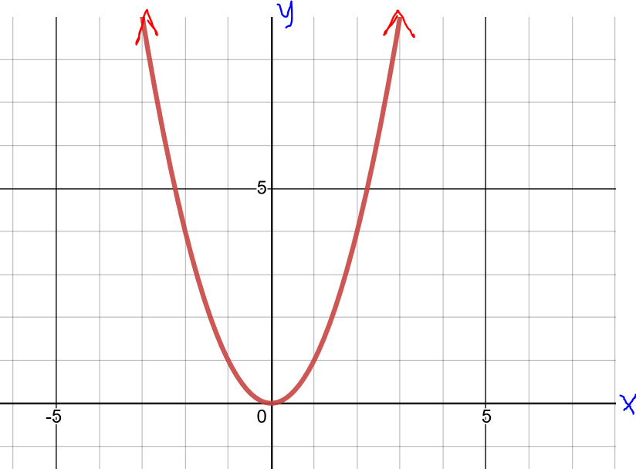

Any real number can be squared, so the domain is **all real numbers**.

Moreover, the graph shows all values from left to right have an output on the graph. To write as an interval, the domain is _____________________or in words, the domain is all real numbers.

*B. Domain is Restricted – ______________________*

Consider the function

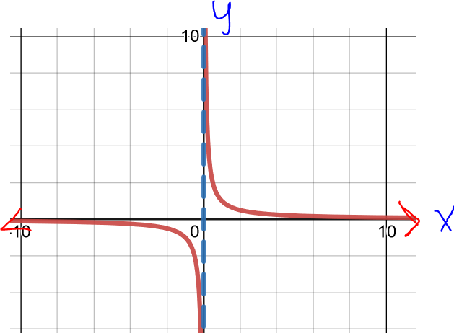

Since division by zero is undefined, the domain is all real numbers _____________________.

Moreover, the graph shows that when there is no output on the graph.

To write as an interval, the domain is ________________

To write as a set; .

*C. Domain is Restricted – _________________________*

Consider the function:

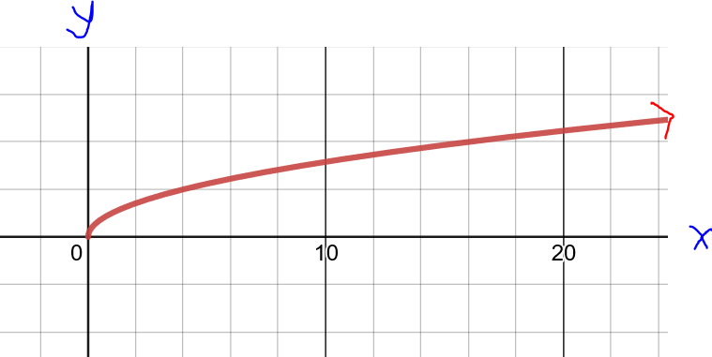

Since negative square roots are undefined with real numbers, the domain is ALL non-negative numbers______________

Moreover, the graph shows that all negative values have no output on the graph.

To write as an interval, the domain is ________________

CONCLUSION: When determining the DOMAIN for a given function, we need to check if there are restrictions on the domain due to **__________________________ OR ____________________**

*Example #1* – Find the Domain of the Function, Write in Interval Notation

The function contains **division** and is ______________ when the denominator is zero (later we will define this type of function as a RATIONAL FUNCTION).

Set the denominator equal to 0 and solve:

A graph shows the same restriction;

notice when there is no output on the graph:

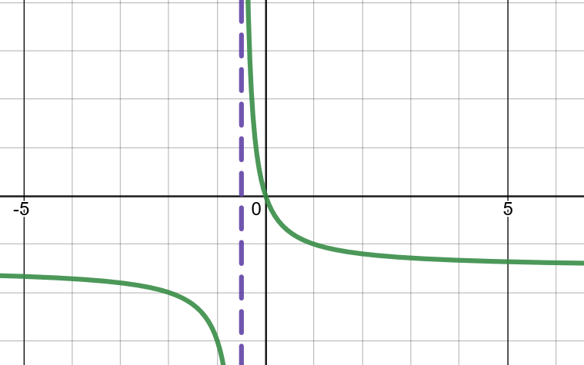

b)

The function does not have **_________________** and does not have **_________________** (later we will define this type of function as a polynomial).

The function is DEFINED for all real numbers; note the inputs have been assigned the variable .

As an interval, the domain is _______________________

A graph shows that there are no restrictions:

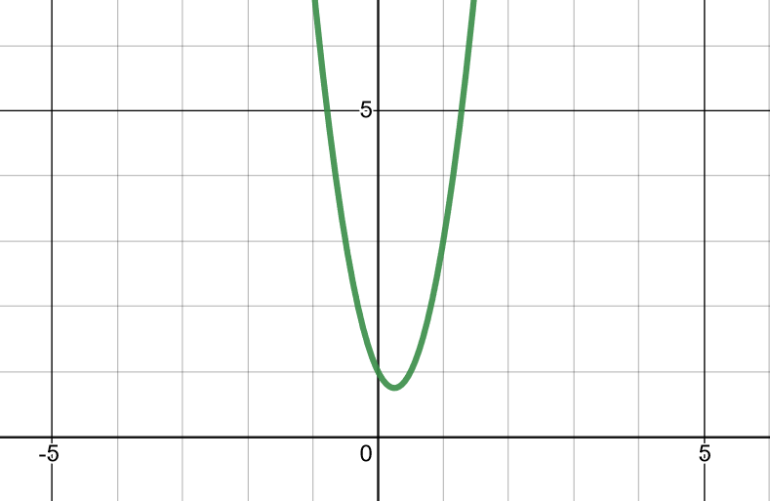

c)

The function contains a **square root** and is ______________________when the radicand (the value under the square root) is negative.

Set the radicand greater or equal to zero (which means non-negative) and solve:

A graph shows that all values for x less than 2/3 have no output on the graph:

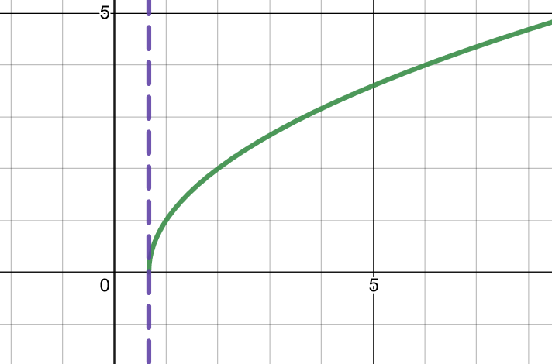

*YOU TRY #1* – Find the Domain of each function. State in interval notation.

a. 

b. 

c. 

d. 

# Topic #2: Combining Functions

Functions possess algebraic properties. Two functions can be combined through addition, subtraction, multiplication, and division (to name a few possibilities) to create a new function.

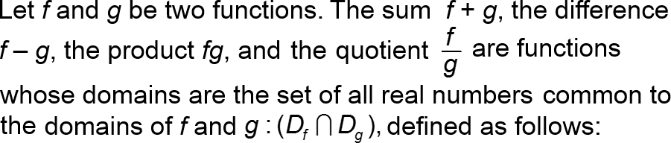

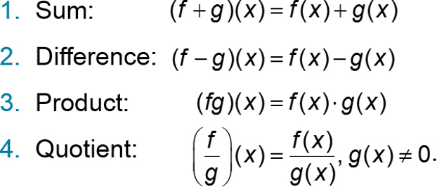

*Example #1* – Combine the Functions

Use the following functions to find the given combination of functions. State any domain restrictions as needed.:

and

a)

b)

c)

*YOU TRY #2* - Use the following functions to find the given combination of functions. State any domain restrictions as needed.:

and

# Topic #3: Composite Functions

Functions have the algebraic property that two functions can be combined by ____________________.

This means one function can be ***plugged into*** another to create a new function.

We can plug function into function to get a new function, the notation is:

and is read as “f of g”.

The inputs/domain/x values go into function first, those outputs then become the new inputs for function .

We can also plug function into function to get a new function, the notation is:

and is read as “g of f”. The inputs/domain/x values go into function first, those outputs then become the new inputs for function .

*Example #1* -

Consider the functions:

and

We can plug function into function :

We can plug function into function :

In both cases, we get a new function. To check the domain, look at the “inner” function first and the new “composite” function last. Both new functions above have no restrictions for the “inner” function and no final restrictions for the “composite/new” function.

*Example #2*-

Consider the functions:

and

We can plug function into function :

We can plug function into function :

In both cases, we get a new function. To check the domain, look at the “inner” function first and the new “composite” function last. Both new functions above have no restrictions for the “inner” function and no final restrictions for the “composite/new” function.

*Example #3* – Compose the Functions, _______________

Let and

a) Find

Plug into :

Replace all inputs for with function , distribute and combine like terms:

b) Find

Plug into

Replace all inputs for with function , distribute and combine like terms:

c) Evaluate

You can also find by first finding *f*(1), and then plugging this output into *g*:

*Example #4* – Compose the Functions, _______________

Let and

a) Find and state its domain.

Plug into :

At this point, there are no restrictions for the “inner” function. Now replace all inputs for with *g*:

The new function has a square root and cannot be negative so there is a restriction on the domain:

b) Find and state its domain.

Plug into :

The “inner” function is a square root and what is the domain restriction?

Now replace the input of with :

Are there any further domain restrictions for the new function? What do we need to do to find them?

c) Find

You can use the composite function from part a):

You can also find by first finding g(10), and then plugging this output into *f*:

*YOU TRY #3-*

Let and

a) Find and state its domain.

b) Find and state its domain.

c) Find

*Example #5* – Evaluate the Composite Function with a Graph

The graphs of functions and follow, use the graphs to evaluate the composite functions.

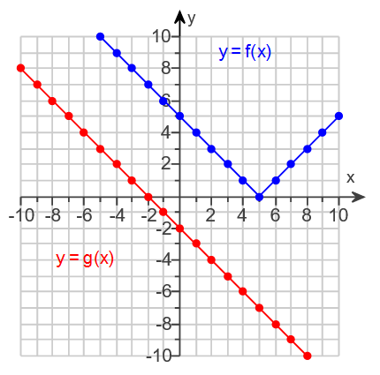

a)

The equations are not given, but we still start with the definition: Use the graph to find the “inner” value:

We input this into the “outer” function:

b) c)

d)

# Topic #4: Decomposition of Functions

Two functions can be composed into one function, and one function can also be decomposed into two functions.

Consider the function

Looking at function we see the “big picture” is _______

However, before that operation happens we multiply by 3 and subtract 1 inside the parentheses.

This demonstrates function can be decomposed into an “inner” and “outer” function:

Evaluate the composite function to confirm by inputting *g*(x) for x in *f*:

*Example #1* – Decompose the Function

Find functions and such that

a)

The big picture is ________________; that is the outer function .

Before that operation, ________________________; that is the inner function :

As a check, you can evaluate the composite functions to confirm that for each example above.

b)

The big picture is _________________; that is the outer function .

Before that operation, ___________________; that is the inner function :

c)

The big picture is _________________; that is the outer function .

Before that operation, ___________________; that is the inner function :

*YOU TRY #4-* Express h(x) as a composition of two functions.

